**Random Forest Algorithm**

* Random forest algorithm is an ensemble learning technique combining numerous classifiers to enhance a model’s performance.
* Random Forest is a supervised machine-learning algorithm made up of decision trees.
* Random Forest is used for both classification and regression problems.

**Ensemble Learning**

Ensemble modeling is **a process where multiple diverse models are created to predict an outcome**, either by using many different modeling algorithms or using different training data sets.

**Bagging-** In adataset, we make different models on the same dataset and combine it,

Bootstrapping- Sampling of data (creating subset of data)

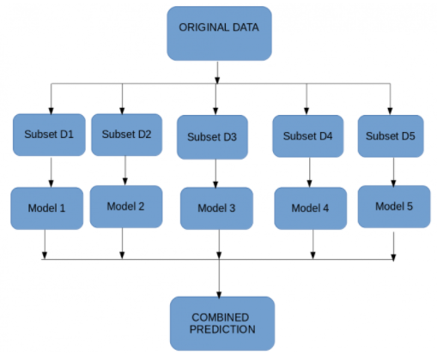

**Boosting** technique is a sequential process, where each model tries to correct the errors of the previous model. The succeeding models are dependent on the previous model.

It combines weak learners into strong learners by creating sequential models such that the final model has the highest accuracy.

For example, ADA BOOST, XG BOOST.

**Process of Random forest Algorithm**

1. A subset of data points and a subset of features is selected for constructing each decision tree.
2. Individual decision trees are constructed for each sample.
3. Each decision tree will generate an output.
4. Final output is considered based on **Majority Voting or Averaging**for Classification and regression, respectively.

**Hyperparameters in Random Forest**

1. **n_estimators:** Number of trees the algorithm builds before averaging the predictions.
2. **max_features:** Maximum number of features random forest considers splitting a node.
3. **max_leaf_nodes:**Maximum leaf nodes in each tree
4. **random_state:**controls randomness of the sample.
5. **n_jobs:**it tells the engine how many processors it is allowed to use. If the value is 1, it can use only one processor, but if the value is -1, there is no limit.